CO1
FLOWGORITHM FLOWCHART
AND PSEUDOCODE ASSIGNMENT
✦ ✦ ✦
Name | M. Yogeshwaran
Register No. | 192524363
Course Name | Java Programming
Course Code | CSA0924

Submitted as part of the Java Programming coursework

Question 1: BMI Calculator
Aim: Read the weight in kilograms and height in metres. Calculate the BMI and classify it as Underweight, Normal, Overweight, or Obese.
BMI Classification Table
BMI Range | Category
BMI < 18.5 | Underweight
18.5 ≤ BMI < 25 | Normal
25 ≤ BMI < 30 | Overweight
BMI ≥ 30 | Obese

Flowchart
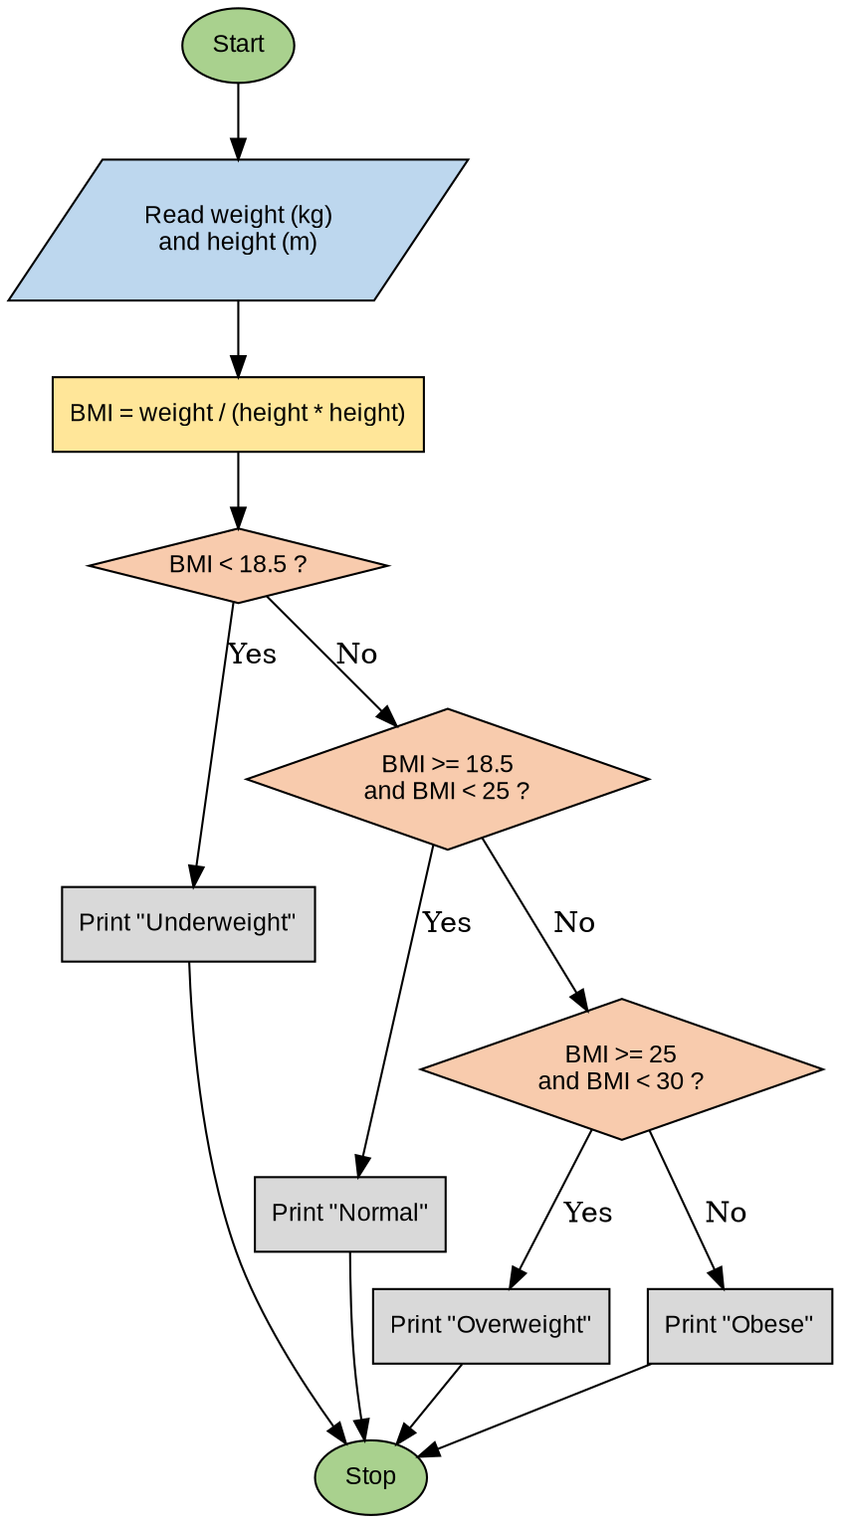
Figure 1.1: Flowchart for BMI Calculation and Classification
Pseudocode
BEGIN
READ weight
READ height
bmi = weight / (height * height)
IF bmi < 18.5 THEN
PRINT "Underweight"
ELSE IF bmi >= 18.5 AND bmi < 25 THEN
PRINT "Normal"
ELSE IF bmi >= 25 AND bmi < 30 THEN
PRINT "Overweight"
ELSE
PRINT "Obese"
END IF
END

Question 2: Check Whether an Array is Sorted (Ascending)
Aim: Read N values into an array and check whether the array is sorted in ascending order.
Flowchart
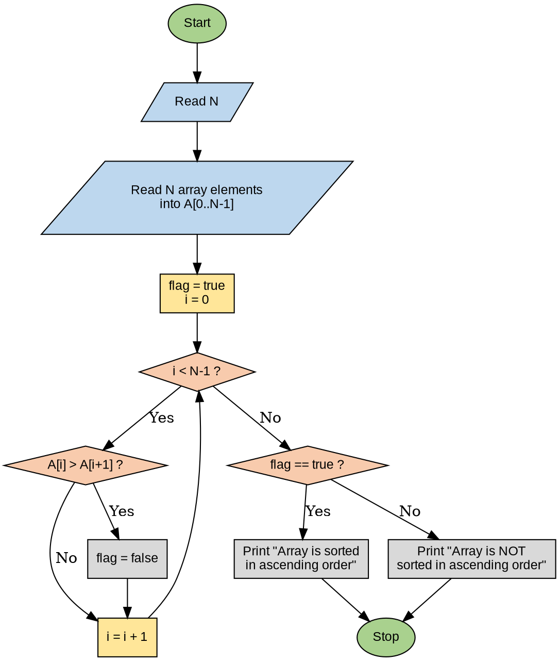
Figure 2.1: Flowchart to Check Ascending Order of an Array
Pseudocode
BEGIN
READ N
FOR i = 0 TO N-1
READ A[i]
END FOR

flag = TRUE
FOR i = 0 TO N-2
IF A[i] > A[i+1] THEN
flag = FALSE
EXIT FOR { array not sorted, break early }
END IF
END FOR

IF flag == TRUE THEN
PRINT "Array is sorted in ascending order"
ELSE
PRINT "Array is NOT sorted in ascending order"
END IF
END

Question 3: Food Ordering System (Regular vs Premium Customer)
Aim: Design a food-ordering flowchart with common order details and different delivery charges for Regular and Premium customers, and relate the design to the concept of inheritance.
Flowchart
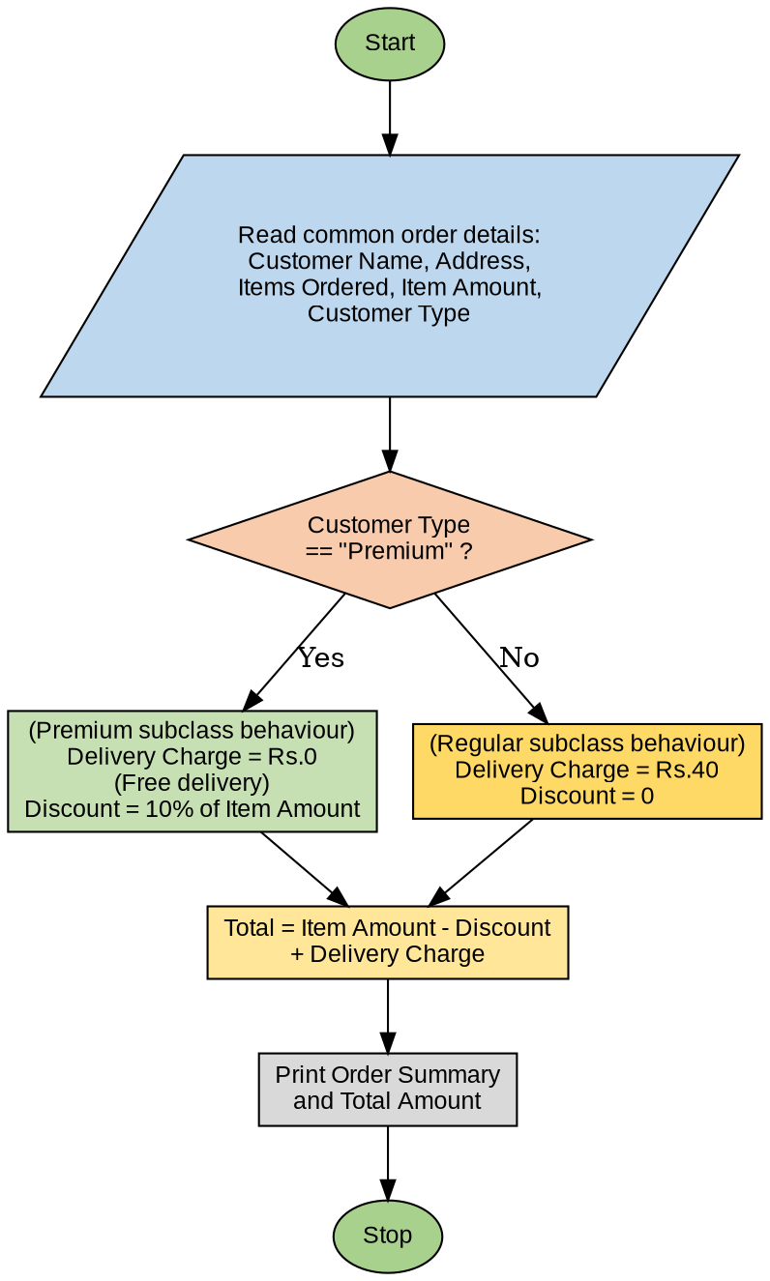
Figure 3.1: Flowchart for Food Order Billing (Regular / Premium Customer)
Pseudocode
BEGIN
READ customerName, address, itemsOrdered, itemAmount, customerType

IF customerType == "Premium" THEN
deliveryCharge = 0 { free delivery for Premium }
discount = 0.10 * itemAmount
ELSE
deliveryCharge = 40 { flat charge for Regular }
discount = 0
END IF

total = itemAmount - discount + deliveryCharge
PRINT customerName, itemsOrdered, deliveryCharge, discount, total
END
Relating the Design to Inheritance
The food-ordering problem naturally maps onto the Object-Oriented concept of inheritance. All customers share a common set of order details (name, address, items ordered, item amount), which forms a base/parent class. Regular and Premium customers only differ in how the delivery charge and discount are computed, which forms the specialised behaviour of derived/child classes.
OOP Element | Class | Contents
Base / Parent class | Customer | customerName, address, itemsOrdered, itemAmount
Derived class 1 | RegularCustomer extends Customer | deliveryCharge = 40, discount = 0
Derived class 2 | PremiumCustomer extends Customer | deliveryCharge = 0, discount = 10% of itemAmount

In Java terms, this can be implemented by writing a Customer class that holds the common order fields and a method computeTotal(), and then having RegularCustomer and PremiumCustomer classes that extend Customer and override (or supply values for) the delivery charge and discount. This avoids code duplication for the common order details, while still allowing each customer type to have its own billing rule — which is exactly the purpose of inheritance in Object-Oriented Programming.
Sample Java Skeleton Illustrating the Inheritance Relationship
class Customer {
String name, address, itemsOrdered;
double itemAmount;

double computeTotal(double deliveryCharge, double discount) {
return itemAmount - discount + deliveryCharge;
}
}

class RegularCustomer extends Customer {
double deliveryCharge = 40;
double discount = 0;
}

class PremiumCustomer extends Customer {
double deliveryCharge = 0;
double discount = 0.10 * itemAmount;
}

